The purpose of this work is to write code to simulate from a multiple regression model and to evaluate some common statistical properties of the simulation.

- Write a program to create 20 simulated datasets from the following linear regression model.
  - N=100, X1= 0 or 1 with ½ in each group, X2 = age, mean = 39 years and SD = 5, X3 = the interaction between X1 and X2. Set beta0 = 1, beta1 = 1, beta2 = 0.5, beta3 = 0.25. Variance of model error = 1.

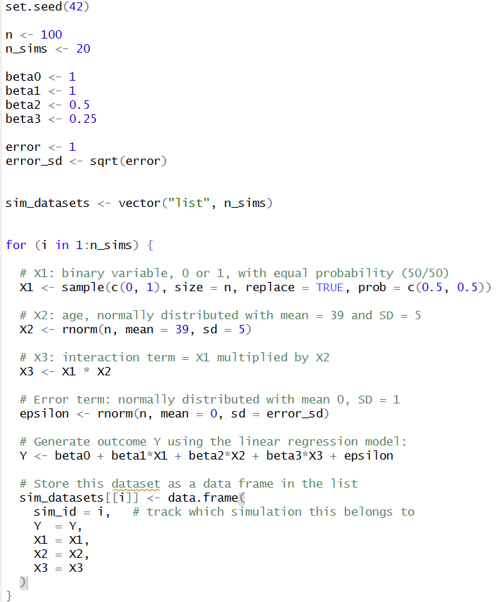

- Plot of the simulated datasets with X2 on the X axis and the simulated outcome on the Y axis. Should we make any changes to the parameters? Is there a reasonable amount of error and variation across the simulated datasets?

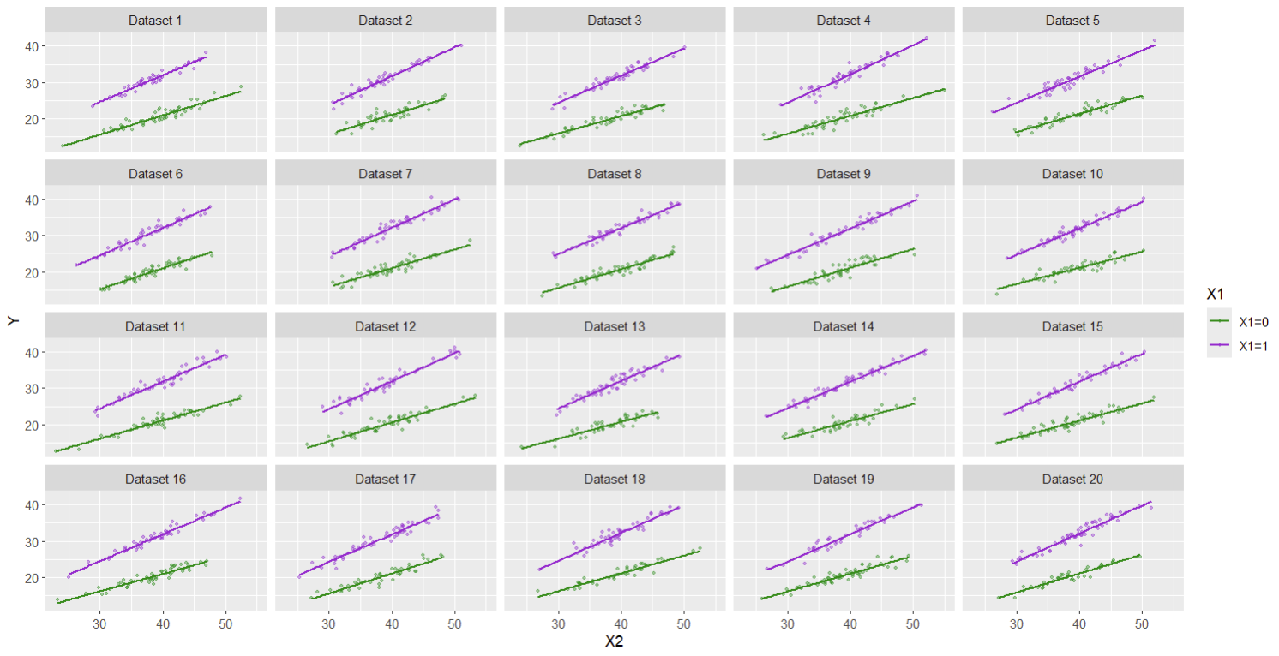

- Summarize the following operating characteristics:
  - Bias of the parameter estimates.
  - Coverage of the 95% CI.
  - Power of the t-tests for each regression coefficient.

- If we also want to calculate the type I error of beta1, beta2 and beta3, can we do it with this simulation? If no, what additional simulation would we need to create.

